# “CLONE OF ROLLS ROYCE WEBSITE”

### A Project report submitted

**In the partial fulfillment the award of degree of**

**BACHELOR OF TECHNOLOGY**

**IN**

**COMPUTER SCIENCE AND ENGINEERING (2022-2023)**

**BY**

**GANITEJA MALLIPAMU**

**211801400002**

**Under the esteemed Guidance of**

**Mrs. G. Rama Devi, M. Tech, (Ph.d),Asst. Professor**

**CENTURION UNIVERSITY SCHOOL OF ENGINEERING AND TECHNOLOGY**

**Rollavaka village, Tekkali mandal 535003**

**(2022-2023)**

##### CENTURION UNIVERSITY OF TECHNOLOGY AND MANAGEMENT

**ANDHRA PRADESH**

**(2019-2023)**

##### DEPARTMENT OF COMPUTER SCIENCE AND ENGINEERING

BONAFIDE CERTIFICATE

##### This is to certify that the project work entitled “CLONE OF ROLLS ROYCE WEBSITE” is a fulfillment of project work done by GANITEJA MALLIPAMU (211801400002) for the award the degree of BACHELOR OF TECHNOLOGY in ELECTRONICS AND COMMUNICATION ENGINEERING, CENTURION UNIVERSITY OF TECHNOLOGY AND MANAGEMENT, during the academic year 2022-2023.

##### INTERNALGUIDE HEAD OF THE DEPARTMENT

##### Mrs .G. Rama Devi Mr. Jogi Naidu

**Asst. Professor Asst. Professor**

**Dept. of CSE Dept. of ECE**

**EXTERNAL EXAMINER**

**ACKNOWLEDGEMENT**

It is with at most pleasure and excitement we submit our project partial fulfillment of the requirement for the award of Bachelor of Technology.

The project is a result to the cumulate efforts, support, guidance, encouragement and inspiration from many of those for whom we have to give our truthful honor and express gratitude through bringing out this project at the outset as per our knowledge.

I convey my special thanks to our project **Guide Mrs. G. Rama Devi(Asst. Professor)** who has guided, encouraged and tremendously supported me to enhance my knowledge with present working of this project to bring out enriching the quality of project.

I express my appreciativeness to Mr. **JOGI NAIDU (Asst. Professor) and Head of the Department,** who facilitated us to providing the friendly environment which helped to enhance my skills in present project.

I would also like to extend my gratitude to **Dr. K. V. G. KRISHNA MURTHY, Dean-School of Engineering And Technology, Centurion University of Technology and Management** who has helped us to attain all the requirements of the project.

I convey my sincere thanks to **Dr. RAMANA RAO, Ph. D Registrar of Centurion University of Technology and Management** who provided us with an opportunity to take on project work in well-equipped laboratories of Computer Science Department in our college.

At the outset, we thank to **Sri. G.S.N.RAJU**, beloved **Vice Chancellor of Centurion University of Technology and Management** who is the back bone by providing for completion of this project, Thank you sir.

**DECLA****RATION**

I hereby declare that the project entitled **“CLONE OF ROLLS ROYCE WEBSITE”** submitted to the fulfillment of award the degree of **B. TECH (ECE)** in **CENTURION UNIVERSITY OF TECHNOLOGY AND MANAGEMENT**, **ANDHRA PRADESH.**

**GANITEJA MALLIPAMU**

**211801400002**

Table of Contents

1. Introduction

1.1 Purpose

1.2 Scope

1.3 Definitions, Acronyms, and Abbreviations

1.4 References

1.5 Overview

2. Overall Description

2.1 Product Perspective

2.1.1 System Interface

2.1.2 User interface

2.1.3 Hardware Interface

2.1.4 Software Interface

2.1.5 Communication Interfaces

2.1.6 Memory Constraints

2.1.7 Operations

2.1.8 Site Adaptation Requirements

2.2 Product functions

2.2.1 Context Diagram

2.2.2 Use Case Diagrams

2.2.3 Use case descriptions /Introductions

2.3 User Characteristics

2.3.1 Prospective Customers

2.4 Constraints

2.4.1 User Interface Constraints

2.4.2 Hardware Constraints

2.4.3 Software Constraints

2.4.4 Data Management Constraints

2.4.5 Operational Constraints

2.4.6 Site Adaptation Constraints

2.4.7 Design Standards Compliance

2.5 Assumptions and Dependencies

2.6 Apportioning of Requirements

3. Specific Requirements

3.1 External Interface

3.1.1 Web Server

3.1.2 HTML

3.1.3 CSS

3.1.4 JavaScript

3.2 Functional Requirements

3.2.1 Home Page

3.2.2 Products Page

3.2.3 Services Page

3.2.4 About Us Page

3.2.5 Contact Us Page

3.3 Non-Functional Requirements

3.3.1 Performance Requirements

3.3.2 Security Requirements

3.3.3 Usability Requirements

3.4 Design Constraints

3.5 Software System Attributes

3.5.1 Reliability

3.5.2 Availability

3.5.3 Maintainability

3.5.4 Portability

1. Introduction

1.1 Purpose

The purpose of this document is to provide a detailed description of the requirements for the Rolls Royce website. It will explain the purpose and scope of the project, the software and hardware interfaces, the constraints, assumptions, and dependencies. This document will also outline the specific functional and non-functional requirements of the website.

1.2 Scope

The Rolls Royce website is a marketing website for Rolls Royce that showcases their products and services. The website will have a home page, a products page, a services page, an about us page, and a contact us page. The website will also feature high-quality images and videos of their products and services, as well as interactive elements that engage the user.

1.3 Definitions, Acronyms, and Abbreviations

None.

1.4 References

None.

1.5 Overview

The following sections of this document will provide a detailed description of the requirements for the Rolls Royce website. The Overall Description section will describe the product perspective, product functions, user characteristics, constraints, assumptions, and dependencies. The Specific

2. Overall Description

2.1 Product Perspective

The Rolls Royce website is an independent website that provides information about the company's products, services, and events. It is intended for customers, investors, and the general public.

2.1.1 System Interface

The system interface is a web browser that is capable of rendering HTML, CSS, and JavaScript.

2.1.2 User Interface

The user interface is designed to be visually appealing and easy to navigate. It includes a home page, a product page, a services page, an events page, and a contact page.

2.1.3 Hardware Interface

The website does not have any specific hardware requirements beyond a device capable of accessing the internet.

2.1.4 Software Interface

The website requires a web server to host the site and a database management system to store and retrieve information.

2.1.5 Communication Interfaces

The website communicates with the server using the HTTP protocol.

2.1.6 Memory Constraints

The website has no specific memory requirements beyond those of the hosting server.

2.1.7 Operations

The website allows users to browse the website, view products and services, register for events, and contact the company.

2.1.8 Site Adaptation Requirements

The website must be adaptable to different screen sizes and devices.

2.2 Product Functions

2.2.1 Context Diagram

The context diagram for the Rolls Royce website is as follows:

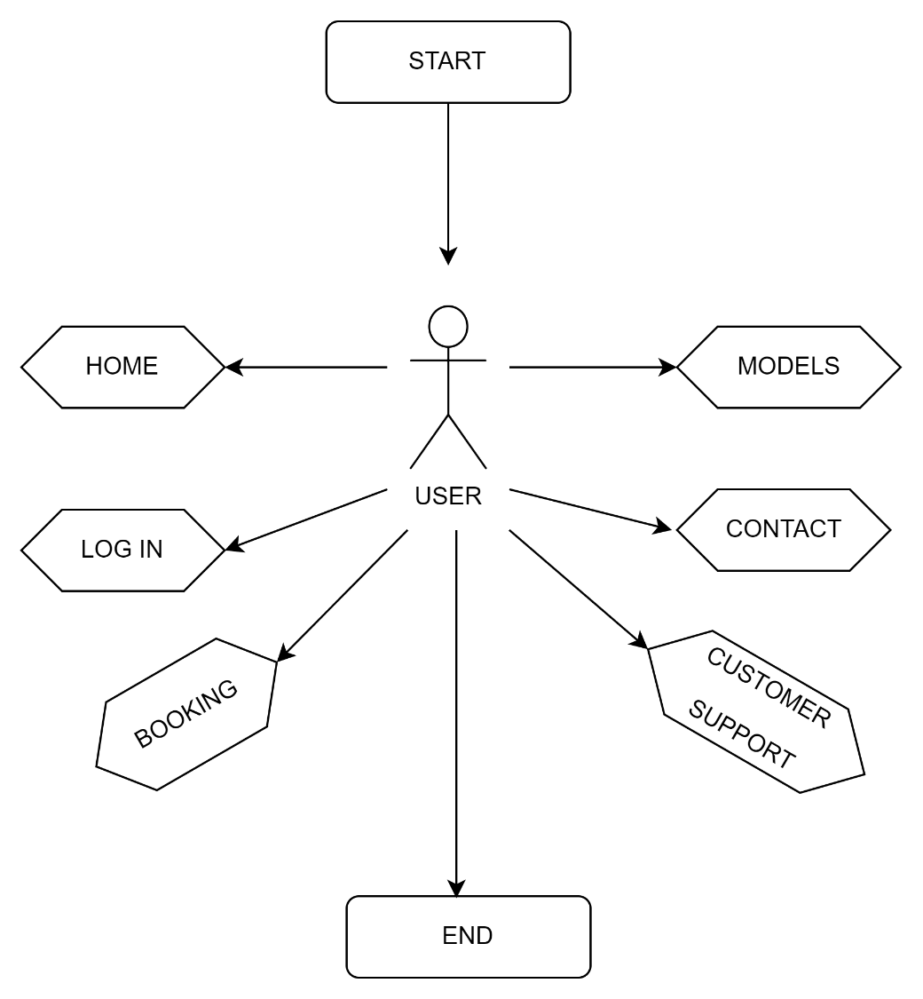

2.2.2 Use Case Diagrams

The use case diagram for the Rolls Royce website is as follows:

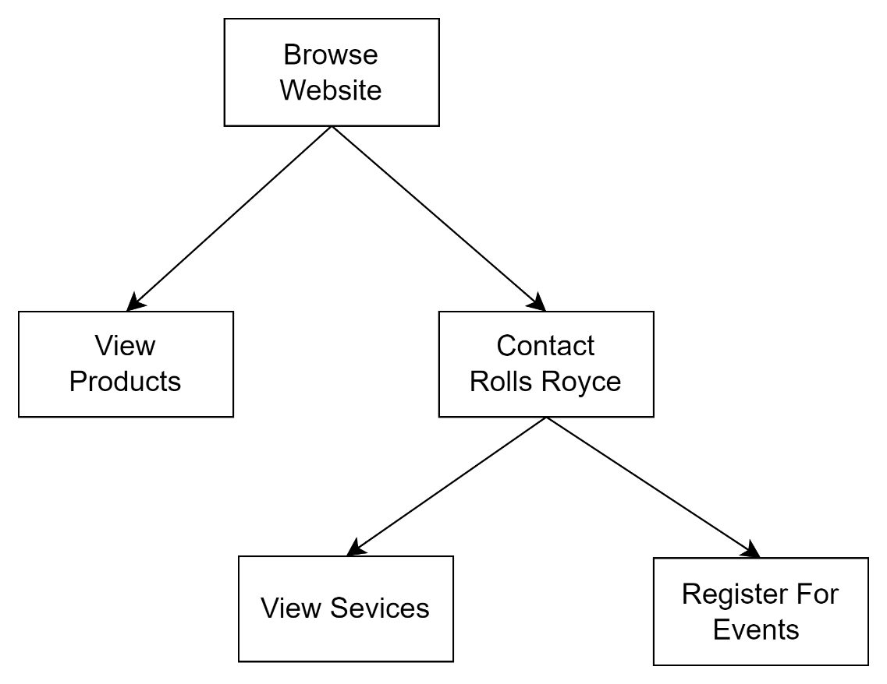

Log in context diagram:

The login context diagram is an important tool to understand the interactions between the system and the user in the login feature. It highlights the inputs and outputs of the login process and the main components of the system involved in this feature, including the login interface, the user database, and the authentication module. This diagram serves as a basis for the development of use case diagrams and use case scenarios that will provide a more detailed description of the login feature's functionality.

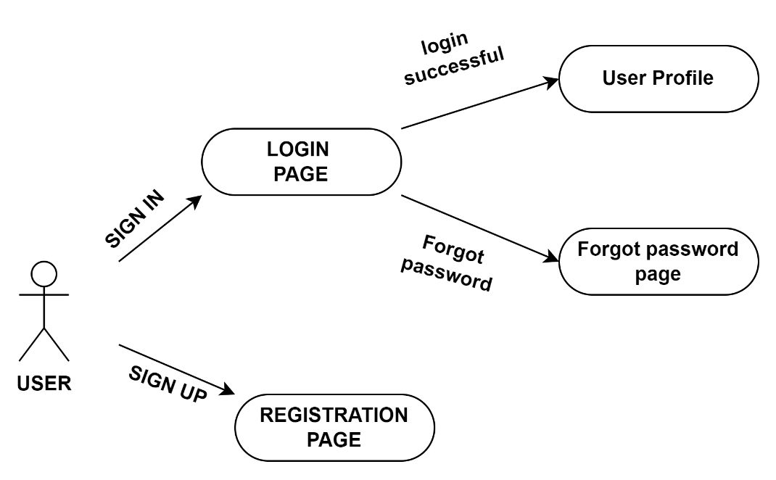

2.2.3 Use Case Descriptions / Introductions:

1. Browse Website: The user can browse the website to learn more about Rolls Royce products and services.

2. View Products: The user can view products offered by Rolls Royce and learn more about them.

3. Contact Rolls Royce: The user can use the website to contact Rolls Royce for more information.

4. View Services: The user can view services offered by Rolls Royce and learn more about them.

5. Register for Events: The user can use the website to register for events hosted by Rolls Royce.

2.3 User Characteristics

The website is designed for a wide range of users, including potential and current customers, investors, and the general public.

2.3.1 Potential Customers

Potential customers are interested in learning more about Rolls Royce products and services.

2.3.2 Current Customers

Current customers are interested in staying up-to-date on Rolls Royce products and services.

2.3.3 Investors

Investors are interested in learning more about the financial performance and prospects of Rolls Royce.

2.4 Constraints

2.4.1 User Interface Constraints

- The website design must be visually appealing, modern and consistent with the Rolls-Royce brand.

- The website must be responsive and compatible with a variety of screen sizes and devices, including desktops, laptops, tablets, and smartphones.

- The website must be user-friendly and easy to navigate, with a clear hierarchy and intuitive menu system.

2.4.2 Hardware Constraints

- The website must be able to run on standard web servers and be compatible with commonly used web browsers.

- The website must be able to handle a large volume of traffic and provide a fast and responsive user experience.

2.4.3 Software Constraints

- The website must be developed using modern web technologies such as HTML5, CSS3, and JavaScript.

- The website must be built on a scalable and flexible platform that can easily accommodate future enhancements and updates.

2.4.4 Data Management Constraints

- The website must be able to handle large amounts of data related to products, services, and customer information.

- The website must have a robust and secure database system to store and manage data.

- The website must be able to integrate with external data sources such as social media platforms and third-party services.

2.4.5 Operational Constraints

- The website must be available 24/7 and provide reliable and consistent performance.

- The website must have a backup and disaster recovery plan in place to ensure data integrity and availability in the event of system failures or outages.

- The website must comply with all applicable laws and regulations related to data privacy, security, and accessibility.

2.4.6 Site Adaptation Constraints

- The website must be adaptable to different languages and cultural contexts to reach a global audience.

- The website must be customizable to accommodate regional variations in products and services.

2.4.7 Design Standards Compliance

- The website must comply with established design standards and best practices for web development, including accessibility and usability guidelines.

2.5 Assumptions and Dependencies

- The successful implementation of the website depends on the availability and functionality of third-party tools and services such as web hosting, domain registration, and payment gateways.

- The website assumes that users have basic computer literacy and internet access.

2.6 Apportioning of Requirements

As the project progresses, additional requirements may emerge, and some requirements may be deemed less critical than others. Therefore, it is important to prioritize requirements in order to ensure that the most critical ones are addressed first. The following apportioning of requirements outlines the priority of each requirement:

1. High priority:

- Responsive and visually appealing website design

- Easy-to-use navigation menu

- Fast loading times

- Secure website with SSL certificate

- Mobile responsiveness

- Clear and concise product information

2. Medium priority:

- Interactive features such as video, 360-degree views, and animations

- Integration with social media platforms

- Advanced search functionality

- Personalized user accounts

- Online payment options

3. Low priority:

- Localization and multilingual support

- Integration with third-party services

- Advanced analytics and reporting

- Integration with existing Rolls Royce systems

Note: The apportioning of requirements is subject to change based on project progress and stakeholder feedback.

3. Specific Requirements

3.1 External Interface

3.1.1 Web Server

The website shall be hosted on a web server that meets the following requirements:

- High availability

- Fast response times

- Secure connection with SSL certificate

- Scalability to accommodate high traffic volumes

- Compatible with the website's technical stack

3.1.2 Technical Stack

The website shall be developed using the following technical stack:

- HTML5, CSS3, and JavaScript for frontend development

- Bootstrap framework for responsive design

- PHP programming language for backend development

- MySQL database for data storage and retrieval

- AJAX for dynamic content loading

3.2 Functional Requirements

3.2.1 Use Case Scenario

The following use case scenario describes the basic functionality of the website:

- User navigates to the website

- User browses the website to view products and services offered

- User selects a product or service to view more information

- User adds the product or service to their cart

- User proceeds to checkout and completes the purchase

3.3 Performance Requirements

The website shall meet the following performance requirements:

- Fast loading times (less than 3 seconds)

- High availability (99.99% uptime)

- Scalability to accommodate high traffic volumes

- Compatibility with a range of web browsers and devices

- Efficient use of server resources

3.4 Logical Database Requirements

The website shall use a MySQL database to store and retrieve data, with the following requirements:

- Secure storage of user data and transaction information

- High availability and scalability

- Efficient retrieval and storage of data

- Data backup and recovery mechanisms

3.5 Design Constraints

The website shall conform to the following design constraints:

- Consistent branding with the Rolls Royce corporate identity

- User-friendly and easy-to-navigate interface

- Responsive design that adapts to different screen sizes and devices

- Fast loading times and efficient use of server resources

- Clear and concise product information

3.6 Software System Attributes

3.6.1 Reliability

The website shall be reliable, with the following requirements:

- High availability and uptime (99.99%)

- Secure and efficient data storage and retrieval

- Automated data backup and recovery mechanisms

3.6.2 Availability

The website shall be highly available, with the following requirements:

- Uptime of 99.99% or higher

- Automated failover and load balancing mechanisms

3.6.3 Security

The website shall be secure, with the following requirements:

- SSL certificate for secure connection

- Secure storage and transmission of user data and transaction information

- Protection against common security threats